**Hello World Declarative Script using Jenkins pipeline**

**Step1:**  Login into Jenkins using username and password (default username and password admin)

**Step2**: Jenkins Dashboard ---> Click New Item ---> Name : simple pipeline job creation with declarative script and select pipeline and click **OK.**

**Step3**: provide description:

**Step4**: go to pipeline section and select **Hello World** from the dropdown menu.

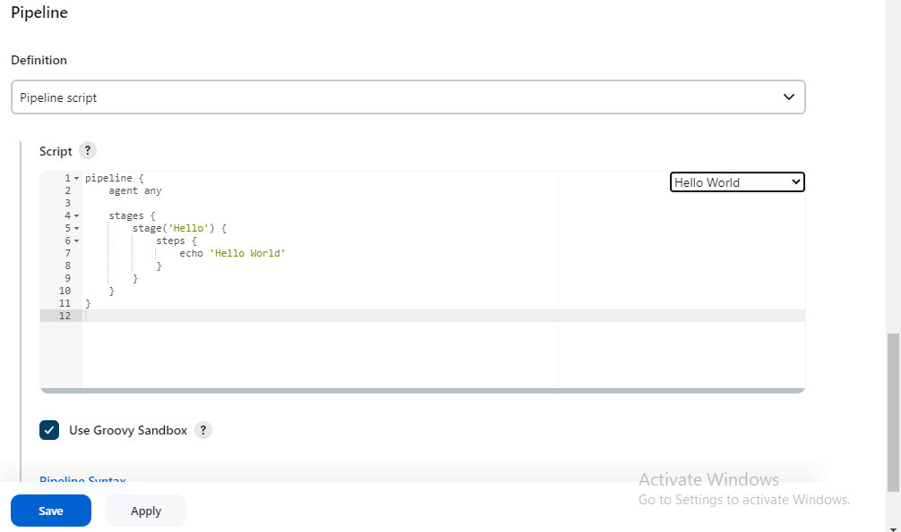

**Step5**: Click Apply and Save

**Step6:** Now click Build Now.

**Step7**: Click build number and click console output for viewing the logs.

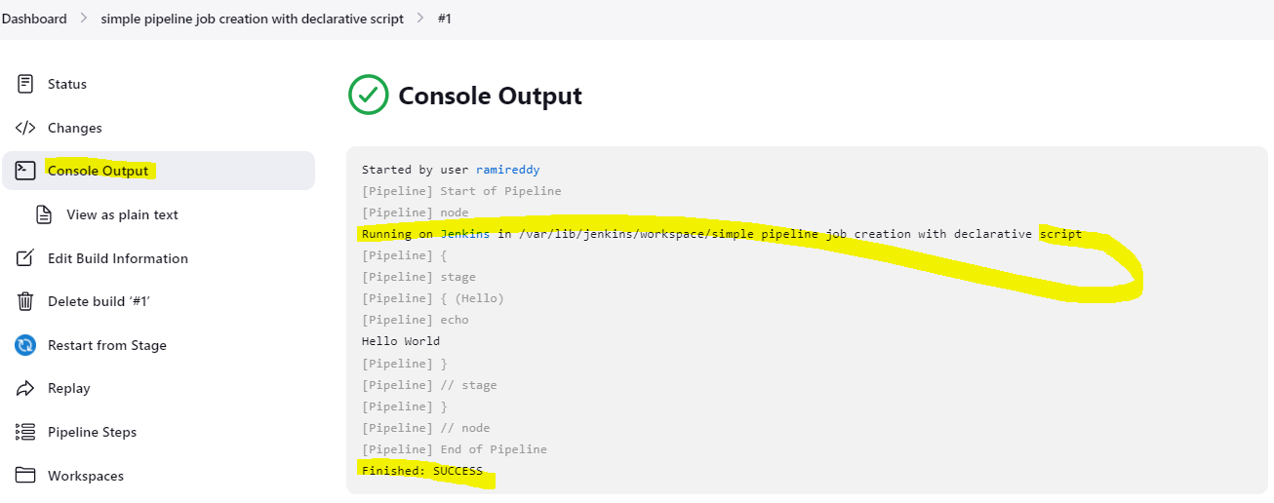

**Step8**: For editing the job click configure.